﻿import pandas as pd

import scipy.stats as st

import random

import numpy as np

from scipy.stats import bernoulli

from scipy.integrate import quad

import matplotlib.pyplot as plt

import seaborn as sns

import math

**a**

def p_x(x, sigma, theta):

p_x = st.norm.pdf(x, theta, sigma)

return p_x

def g_x(x,theta):

g_x = 0

bottom = np.sin(x-theta)**2

top = np.sin(5 * (x - theta))

if bottom is 0:

g_x = 0

else:

g_x = (top**2) / (25*bottom)

return g_x

def g_zero(x,theta):

g_zero = 1 - g_x(x,theta)

return g_zero

def a1a(x):

left = g_zero(x,0)

right = p_x(x, 4, 0)

result = left * right

return result

#def ber(x, theta):

#f_x = 0

#f_x = f_x(x,theta)

#bernoulli = bernoulli(f_x)

#return ber

def integrand(a,b,n):

temp, size_spacing = np.linspace(start = a, stop = b, num = n, retstep = True)

result = 0

for i in temp:

result += a1a(i)*size_spacing

return result

﻿a1a_answer = round(integrand(-20, 20,10000),2)

print("1a: The answer is %s"%a1a_answer)

﻿1a: The answer is 0.8

**B**

﻿# 1 b

x_seq = np.random.normal(0, 4, 1)

u = np.random.uniform(0,1)

def rejection_sampling(x,iter=10000):

sample = []

x_sample = []

accept = 0

reject = 0

while accept < iter:

x_temp = np.random.normal(0, 4, 1)

u = np.random.uniform(0,1)

if u < g_x(x_temp,0):

accept +=1

sample.append(u)

x_sample.append(x_temp)

else:

reject +=1

return accept, reject, sample, x_sample

accept, reject, sample, x_sample = rejection_sampling(x_seq,iter=10000)

fraction = round(accept/(reject+accept),4)

print("1b: The fraction of accepted samples %s"%fraction)

plt.hist(sample)

plt.show()

plt.savefig("b")

fraction is 0.2023

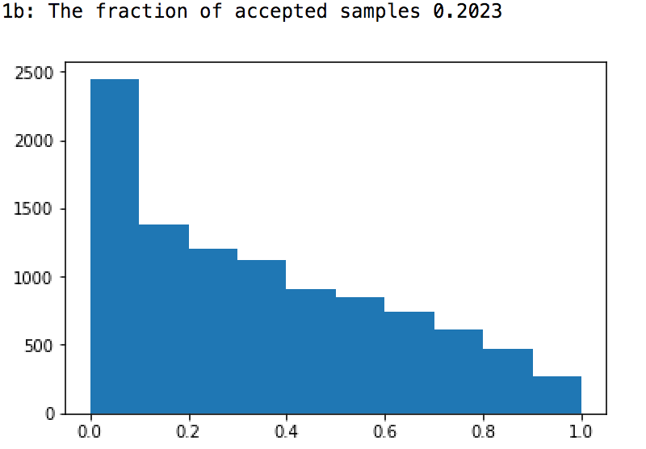

**C**

﻿# 1 c

# after cancallation the self-normalized importance sampler is 1/k * sum(f(xi))

# f'(x) is 1 - g_x()

def self_normalized(x,iter=1000):

sample = []

x_sample = []

accept = 0

reject = 0

while accept < iter:

x_temp = np.random.normal(0, 4, 1)

u = np.random.uniform(0,1)

if u < (1-g_x(x_temp,0)):

accept +=1

sample.append(u)

x_sample.append(x_temp)

else:

reject +=1

return accept, reject, sample, x_sample

accept, reject, sample, x_sample = rejection_sampling(x_seq,iter=10000)

fraction = round(accept/(reject+accept),3)

print("1c: The fraction of photons absorbed is %s"%fraction)

﻿1c: The fraction of photons absorbed is 0.198

**D**

﻿#1 D

def theta_function(theta):

bottom = 10*math.pi*(1+(theta/10)**2)

t_f = 1/bottom

return t_f

def a1d_func(theta):

current_theta = theta_function(theta)

left = p_x(1.7, 4, theta) * current_theta

right = g_x(1.7,theta)

result = left * right

return result

theta_seq = np.arange(-20,20,0.004)

a1d_y = a1d_func(theta_seq)

plt.plot(theta_seq,a1d_y)

plt.show()

plt.savefig("d")

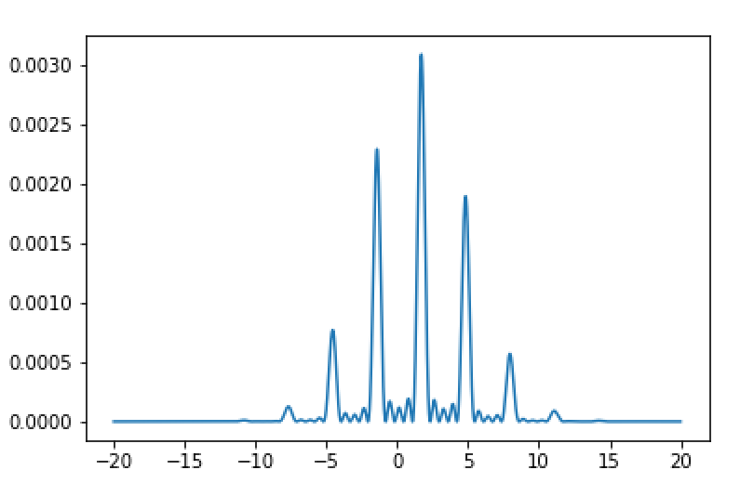

E

﻿def sample_func(theta):

return theta_function(theta) * g_x(1.7,theta)

def metropolis(iters, sd, init):

samples = np.zeros(iters)

n_accept = 0

theta = init

for i in range(iters):

prop = np.random.normal(theta, sd)

px = st.norm.pdf(theta, prop, sd) * sample_func(prop)

qx = st.norm.pdf(prop, theta, sd) * sample_func(theta)

# compute acceptance probability

p_accept = np.minimum(1, px/qx)

if np.random.rand() < p_accept:

# accept

theta = prop

n_accept += 1

samples[i] = theta

return samples, 1. * n_accept / iters

sample_e, fraction = metropolis(10000, 1,0)

plt.hist(sample_e,bins=1000)

plt.title("initial theta = 0, sigma = 1")

plt.show()

plt.savefig("e1")

sample_e, fraction = metropolis(10000,2,0)

plt.hist(sample_e,bins=1000)

plt.title("initial theta = 0, sigma = 2")

plt.show()

plt.savefig("e2")

sample_e, fraction = metropolis(10000,4,0)

plt.hist(sample_e,bins=1000)

plt.title("initial theta = 0, sigma = 4")

plt.show()

plt.savefig("e3")

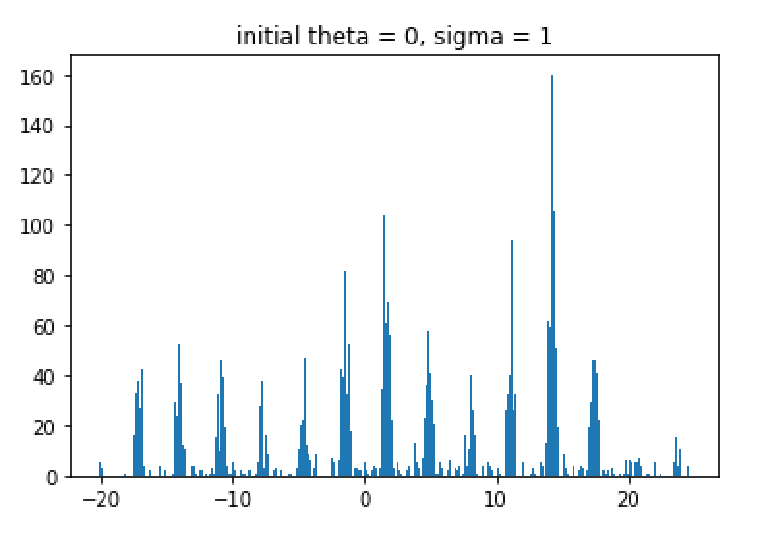

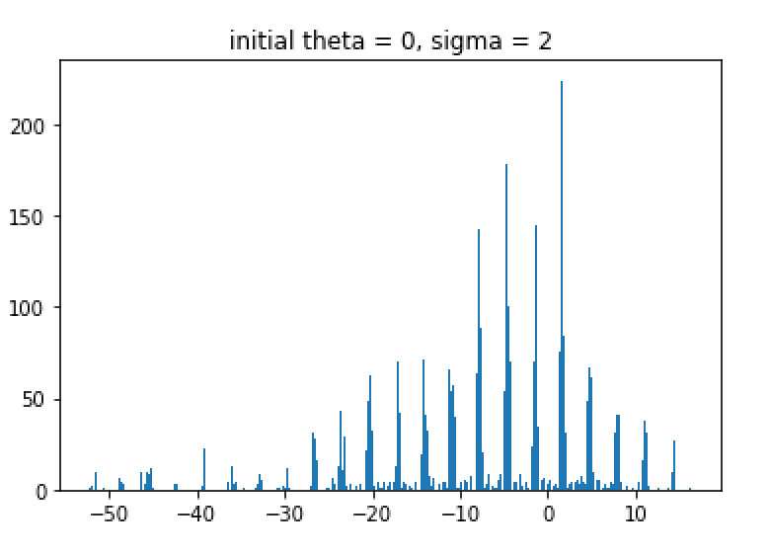

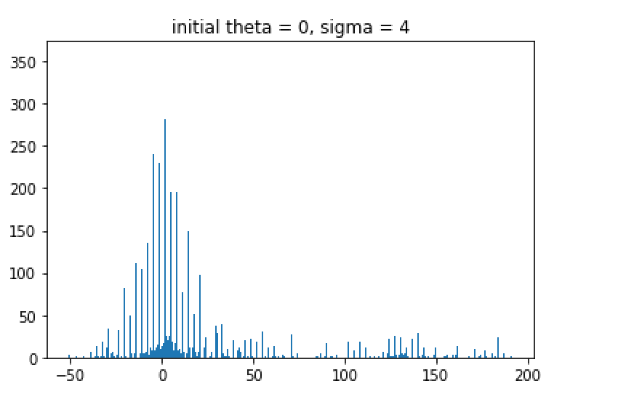

**F**

﻿#1 f

theta_seq = np.arange(-3,3,0.001)

def posterior_probability(init,iters):

samples = np.zeros(iters)

n_accept = 0

reject = 0

for i in range(iters):

theta = init[i]

p = p_x(1.7,theta, 4) * theta_function(theta) * g_x(1.7,theta)

# compute acceptance probability

if -3 < p < 3:

# accept

n_accept += 1

else:

reject +=1

samples[i] = p

return samples, 1. * n_accept / iters

samples, fraction = posterior_probability(theta_seq,6000)

af = round(fraction,2)

print("1f: The fraction of calibrated to within 3 degrees around zero is %s"%af)

﻿1f: The fraction of calibrated to within 3 degrees around zero is 0.5